Jabber Getting Started – PC and Mac

* If you are a call center agent working remotely, sign into Purdue VPN. Instructions are provided in the link below. If you are not a call center agent or working on campus, VPN is not required. <https://www.itap.purdue.edu/newsroom/200318_usewebvpn2.html>.
* Make sure Jabber is installed on your computer and that you have a headset. CSDS machines should have it available in the Software Center. Personally owned machines can download the software in Software Central at <https://communityhub.purdue.edu/storefront/product/jabber_personal>.
* Jabber (and Finesse if you are a call center agent) MUST be running on the local computer you are using. NOT your remote computer in the office.
* Launch Jabber and sign in with your alias-based email address

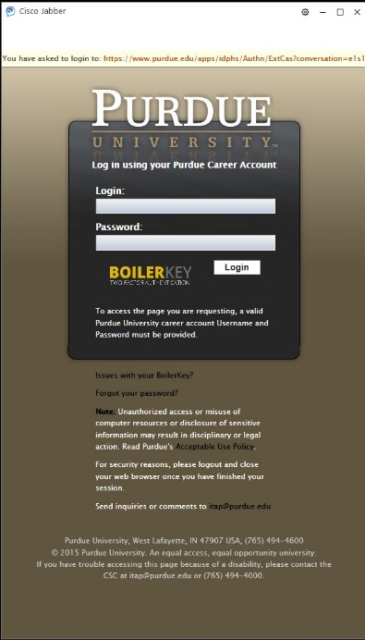

* After logging in you will see a spinning circle in the lower right corner. If signing in for the first time on the campus network or over VPN, Jabber may default to controlling your desk phone. You must manually change it to soft phone mode. Once the spinning circle changes to a green icon, enter softphone mode by clicking the icon as shown in the screenshot and choosing Use My Computer as the device for calls.

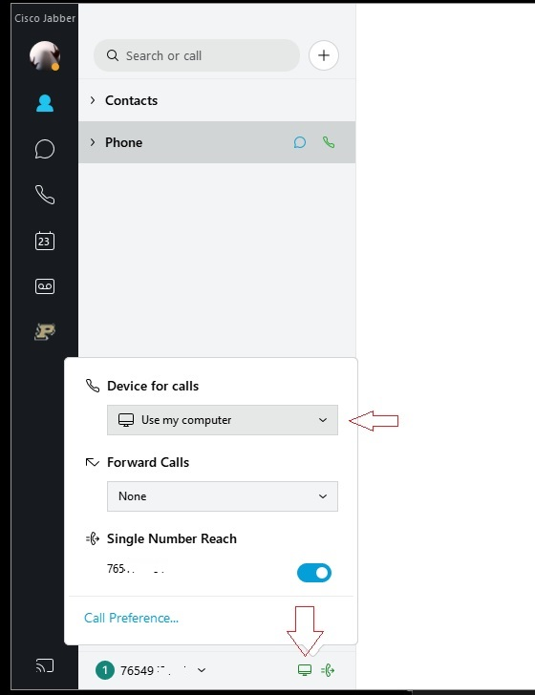

* If you have more than one line assigned, you should see your personal office number as well any others added to your account in the line selection box. Whichever line is selected in this box is the line your Jabber software will use for an **outgoing** call. If you are a call center agent, you should select your call center line if returning a call to a customer. All lines configured will ring in if called. They do not need to be selected first.
* NOTE- If you only have a single line assigned, the line selection box will NOT appear.

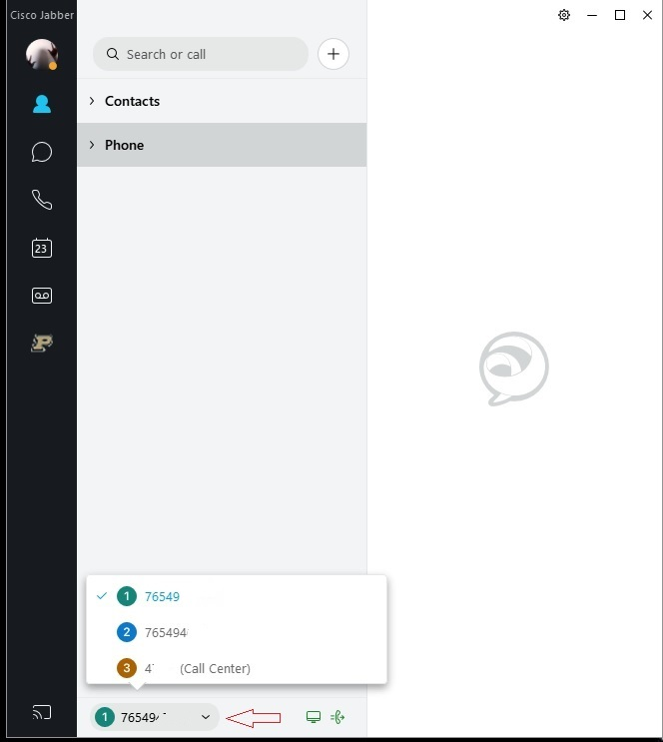

• Verify your headset is configured in Jabber by clicking the gear icon in the upper right, choosing settings, then choosing the audio tab. You should select your headset in the speaker and microphone box.

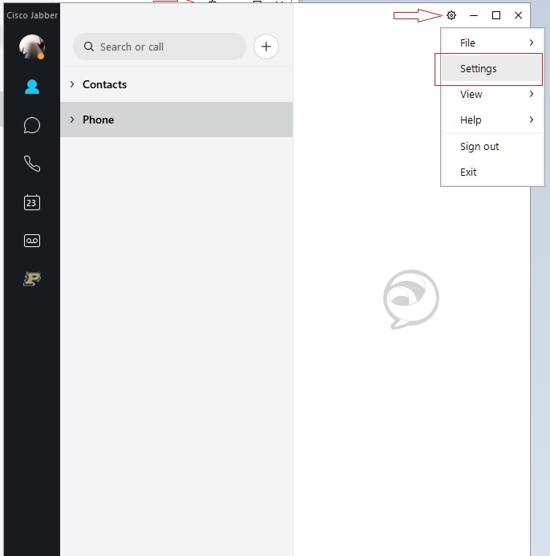 7

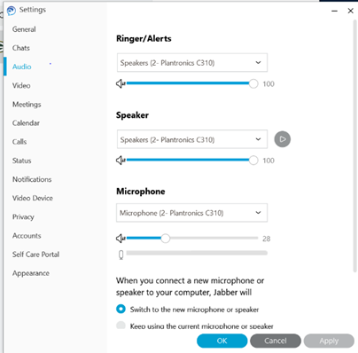

* After verifying your headset, please make a call from Jabber to cell phone or from your cell phone to your Jabber client to test your headset and audio. To place a call from Jabber, enter the number in the search bar exactly as you would dial from a campus phone and click the phone icon to dial.
  + 5-digit campus number
  + 7+(7digit local number)
  + 7+1+(10-digit long distance number)

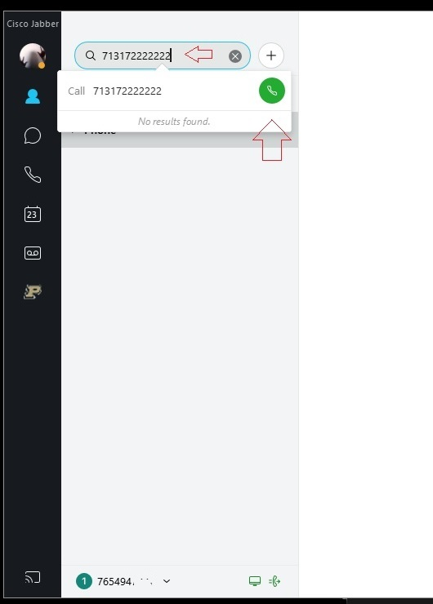

* Here are some additional tips if your headset is not working:

Under settings (click on your initials on the left side of Jabber) click Audio and ensure that the correct headsets are selected:

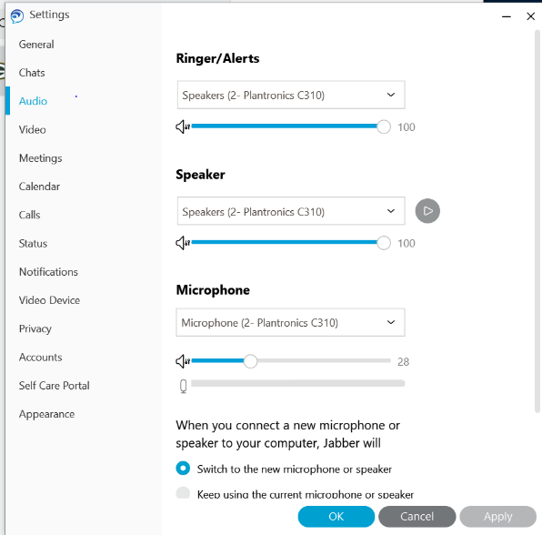

Scroll down to “Advanced” and click to open

Move your headset to the top of the priority list as shown below:

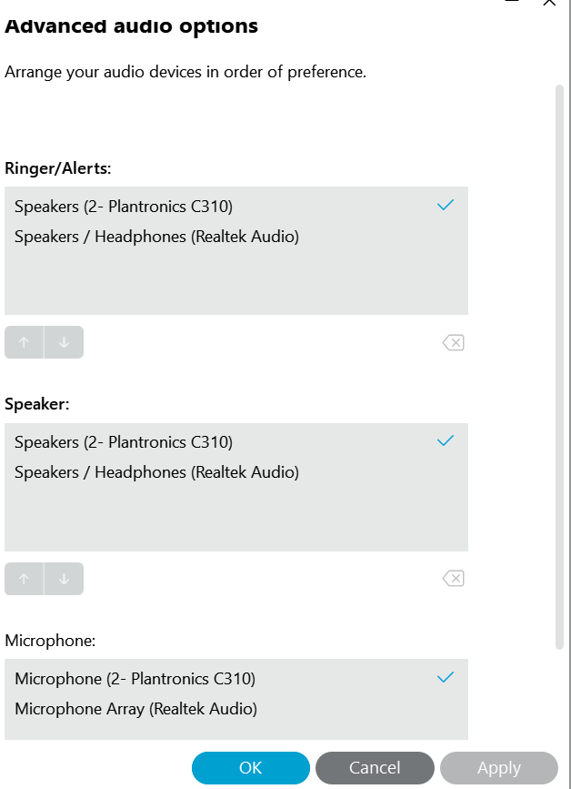

**Troubleshooting Services:**

You may not see phone and voicemail services connecting on the first sign in after install as configuration has been downloaded that may not immediately take effect. Service status can be verified in the help menu under Show Connection Status. If this occurs, click the gear icon, sign out, then sign in a second time. You can also try setting the Device for calls to none, then back to use computer.

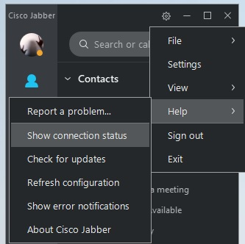

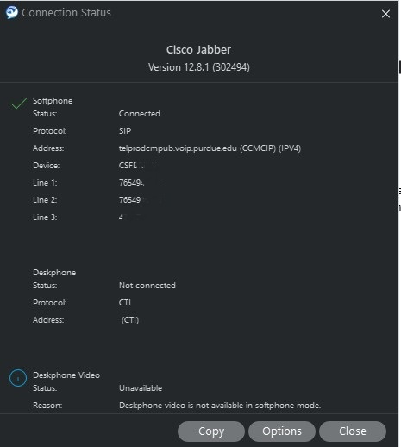

**Finesse Tips** (Call Center Agent):

Be sure that Device for Calls is set to “Use my computer”. If Jabber is not registered in softphone mode, Finesse sign in will always fail.

Once you have all of this set up and properly running, launch [Cisco Finesse](https://telcontactcenter1.voip.purdue.edu:8445/) on your local workstation, and log in as you normally would.

Order of log in:

* + Log in to your computer
  + Log in to webvpn2.purdue.edu via Cisco AnyConnect VPN client (if working remote)
  + Log into Jabber. Place in softphone mode.
  + Log into Finesse using your normal agent log in.

**MANAGING MESSAGES**

**From your Phone, Off Campus and the Web**

**Voicemail Access Number: 45111**

# **WELCOME TO PURDUE UNIVERSITY’S UNITY CONNECTION VOICEMAIL**

**QUICK VOICEMAIL SET UP**

1. Click the   **icon.**
2. Click Call Voicemail or dial 45111
3. Enter your **initial PIN number 12345**, then press **#**

(pound).

1. The “Welcome” tutorial will start where you will **record a**

**first/last name.** Press **#**.

1. Use the standard greeting with your name or personalize by pressing **1** to **record a greeting**, then **#** to save.
2. Change your PIN, **confirm** and Press **#**.

## This system allows you to listen to your voicemail from your office phone, from another user’s phone, off campus network phone, and by using the visual voicemail feature. Voicemail access # **45111**.

**COMMON VOICEMAIL COMMANDS**

**Commands**

**Action Key(s)**

**Play** messages 1

**Save** message 2

**Delete** messages 3

**Change** greeting 4 11

**Change** PIN 4 3 1

**Change** recorded name 4 3 2

**AFTER MESSAGE MENU COMMANDS:**

**Commands**

**Action Key(s)**

Replay message 1

Play previous message 14

Play next message 16

Play first message 17

Play last message 19

Delete 3

Reply 4

Reply to all 42

Call the sender 44

(Available only to Unity Users)

Forward message 5

**DURING MESSAGE MENU COMMANDS:**

**Commands**

**Action Key(s)**

Restart message 1

Play message by number 12

Play previous message 14

Play next message 16

Save 2

Delete 3

Reply 4

Reply to all 42

Return call to sender 44

Forward message 5

Slow playback 64

Fast playback 66

Change volume 65

Reset volume to default level 63

Rewind message 7

Pause or resume 8

Fast-forward 9

Fast-forward to end 17

Play last message 19

**SIGN IN FROM OFF CAMPUS**

To retrieve your Unity Connection voicemail messages from any phone outside the Purdue network, you have two choices:

**CALL YOUR OWN PURDUE PHONE NUMBER**

1. When your greeting begins to play, press the **\* (star)**

**button.**

1. When prompted, enter your **10-digit Purdue number**,

then **#** (pound).

3. **Enter** your **Unity Connection PIN**, followed by **#**

(pound).

OR

**CALL 494-5111**

When voicemail answers, you will be asked to **enter** your **10-digit phone number**, then **#**. Next, **enter** your **PIN,** followed by **#** (pound). Note: if you have single number reach using your cell phone, you will only enter your **PIN**, followed by **#** (pound).

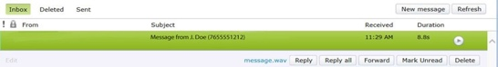

# **UNITY CONNECTION WEB INTERFACE**

## **SIGN IN OVER THE WEB**

1. Open the **Unity Connection Global Access Portal** at:

[*http://voicemail.voip.purdue.edu*](http://voicemail.voip.purdue.edu/)

1. In the Username field, enter your **Purdue user ID**.
2. In the Password field, enter your **Purdue career account password**.
3. Click the **Sign In** button.

## **PLAYING A MESSAGE USING THE WEB**

1. Click the **Messages** tab.

## **SENDING, REPLYING, & FORWARDING**

You can send voice messages to Cisco Unity Connection users, private distribution lists that you create and system distribution lists.

1. For best voice quality, click the **Phone** button in the lower right corner of the Inbox.
2. Click the **New Message** button or select a **message** and then click the **Reply**, **Reply all** or **Forward** button.

3. In the To, Cc or Bcc fields, begin typing a **recipient name**, **the name of one of your Private Distribution lists** or a **system distribution list**. As you type, a list of possible matches appears. Click the **name you want to add**. Voicemail recipients are separated with semicolons (;).

1. At the bottom of the Inbox, click the **Phone or Computer** button to select which device you will use for recording and playing voicemail messages. When the Phone is selected, put your **10-digit extension number** in the box next to phone.
2. Click a **message** from the Inbox to select it.
3. Click the **Play** button. The voicemail message will play on your computer or your phone will ring and the message will play when you answer the phone.
4. Click **Play** button in green bar to replay the message from that point.

## **Reset or Change Voicemail PIN**

1. Select the Settings button on the top left to open the Personal Options page.
2. On the Personal Options page, select the Passwords drop-down menu and select Change PIN.

**VISUAL VOICEMAIL**

View a list of messages on your soft phone. Play, delete, forward, and save messages without having to dial.

your box. Available only on 8900 models.

**ACCESSING VISUAL VOICEMAIL**

1. Click the icon.

2. Visual Voicemail displays a list of your voice messages.

**PLAYING MESSAGES**

1. **Highlight** the message you want

to play.

1. To play the message, click the **Play** icon.
2. To delete, press the **Delete** icon.
3. [OPTIONAL] Add or modify the **Subject**.
4. [OPTIONAL] Check **delivery options** as needed:
   * Urgent • Private • Read Receipt

## **TO RECORD A MESSAGE**

1. Click the **Start Recording** button.
2. If you selected to manage your messages over the phone, pick up the phone when it rings and **record your**

**message** using the headset or handset. Otherwise record the message over the computer’s microphone or a USB headset.

1. Click the **Stop Recording** button when your message is complete.
2. [OPTIONAL] Click the **Play Recording** button to listen to the message.

5. [OPTIONAL] Press the **Start Recording** button to re-record your message, if you wish.

6. When you are satisfied, click the **Send button**.

**To forward all calls to voicemail, use 45111.**